**Project Plan: BiteNow**

**Green Team**

**Team Members:** Emmanuel Akinseye, Ann Chen, Ryan Engelken, Maurice Farr, and Harjot Singh

Department of IT, Ivy Tech Community College

Dr. Carver

SDEV-265

April 2, 2025

Tables of Contents

**Project Plan:** **3**

**Introduction:** **3**

**Project Organization: 4**

**Risk Analysis: 5-6**

**Hardware and Software Requirements: 7**

**Work Breakdown: 8**

**Project Flow Diagrams****:** **9-11**

**Project Schedule: 12**

**Monitoring and Reporting Mechanisms: 13**

**Appendix: 14-15**

## **Project Plan:**

Our project aims to establish a food delivery service website named BiteNow, drawing inspiration from the well-known platform DoorDash. For more information, proceed to the “Introduction” section.

## **Introduction:**

The purpose of our group project is to develop a website that replicates the functionalities of the food delivery service DoorDash. The goal of this project is to make delivery simple and enjoyable for customers by providing an intuitive interface where users can explore local restaurants in Indiana and receive meals quickly and conveniently. To complete this mission, we plan to take advantage of reliable web technologies and efficient backend systems to ensure a smooth experience for both the user and restaurant partners, all while maintaining security and scalability.

Furthermore, the project faces constraints in both time and resources. The website's development is required to be finalized within an 8-week timeframe, with a deadline set for May 8, 2025. Although we are not operating on a real actual budget for this project, ideally, it would be best to have a fixed budget to effectively distribute funds across development, testing, and deployment. In addition, our team size is limited, as this will require efficient collaboration and task delegation.

## 

**Project Organization:**

| ***Position*** | ***Names*** | ***Description*** |
| --- | --- | --- |
| *Technical Writer/*  *Support Developer* | Ann Chen | Focuses on documentation/writing assignments while contributing to code. |
| *Technical Writer/Support Developer* | Emmanuel Akinseye | Develops code for our website and conducts tests to ensure it operates properly. Additionally, he plays a role in the project by completing writing assignments. |
| *Team Lead / Programmer* | Harjot Singh | Designated leader of Team Green, and writes code for website project (using programming languages HTML, CSS, and JavaScript) |
| *Organizer/Technical Writer* | Maurice Farr | Responsible for ensuring that the team fulfills the necessary tasks to complete the project while also maintaining oversight of all materials involved. Additionally, he will contribute to the writing and documentation of essential assignments. |
| *Tester/Programmer* | Ryan Engelken | Helps write code for our website, ensures our website/program runs smoothly and does not have any design flaws in it. |

**Risk Analysis:**

| **Risk** | **Description** | **Risk Planning** | **Risk Priority** |
| --- | --- | --- | --- |
| Unable to Deliver on Time  **(Schedule Risk)** | Our product is not finished by the deadline, or we do not have a fully functioning product. | We will adhere to our plan we have scheduled. We will also have weekly check-ins with all team members twice a week. | **High Risk** |
| Debugging Isn’t Completed  **(Operational Risk)** | We don’t have the time or the skill set to debug our project, which in turn causes our product not to function properly. | We are testing as we make changes to our website. When we do our final test, all should work well. | **High Risk** |
| Project Idea Changes  **(Scope Creep Risk)** | We decided to change our project/website from being BiteNow to another website. | If we did change our website for any reason, we could at least keep the same styling/format. | **Moderate Risk** |
| Lack of Expertise  **(Skills Resource Risk)** | We are unable to make the website as described due to our not knowing how to properly code what is needed. | We are starting to code our website early to give us more time to research if we don’t understand something or know how to do it. | **Moderate Risk** |
| Budget Expenses  **(Cost Risk)** | Hosting the website or database is more expensive than we thought. We aren’t charging our users the correct amount per order. | We have done thorough research to know what our budget is. With similar apps, we are able to compare costs. | **Moderate Risk** |
| Poor Performance  **(Performance Risk)** | The website doesn’t perform well, doesn’t update in real time, and doesn't load quickly. | We will be testing as we are updating the website to verify full functionality. | **Low Risk** |
| Cloud Software Failure  **(Technology Risk)** | Google Drive or GitHub goes down. | These are well-known companies; even if one did have issues, they wouldn’t be down for long. We also have copies on all of our personal devices. | **Low Risk** |
| Team Members Not Available  **(Communication Risk)** | We are unable to get in contact with a member of our team. | We have various communication methods, such as phone and Discord. | **Low Risk** |

## 

**Hardware and Software Requirements:**

* **Hardware Requirements:** The hardware for this project will consist of our personal

computers (PCs), which will be employed to complete the necessary assignments and

project tasks.

* **Software Requirements:** On the software side, we will primarily use Visual Studio Code

as our integrated development environment for Python programming. The frontend

development will incorporate HTML, CSS, and JavaScript, while the backend will leverage

a robust framework like Django. For database management, we will utilize SQLite to handle

user data, restaurant menus, and order history. Additionally, we will implement APIs to

integrate third-party services, including mapping for location tracking.

## 

## 

## 

## 

## **Work Breakdown:**

1. **User Registration and Authentication**

* **Activity 1.1:** Design the registration and authentication (front-end and back-end).
* **Activity 1.2:** Implement registration and authentication functionality.
* **Activity 1.3:** Test user registration, login, and authentication flow.

2. **Location**

* **Activity 2.1:** Implement a map for the state of Indiana.
* **Activity 2.2**: Verify the map's visibility by inputting a zip code.

3. **Restaurant Menu Browsing**

* **Activity 2.1:** Implement front-end and back-end functionality to fetch and display menus.
* **Activity 2.2:** Test menu browsing, including search functionality.

4. **Order Placement**

* **Activity 4.1:** Design the order placement page.
* **Activity 4.2:** Implement order placement functionality.
* **Activity 4.3:** Test order placement.

5. **Final Integration and Testing**

* **Activity 5.1:** Integrate all modules into the final version.
* **Activity 5.2:** Conduct comprehensive system testing, covering user scenarios. If any problems arise during the testing process, we will address and resolve them as needed.

\

**Process Flow Diagrams:**

* User Registration Flow Diagram:

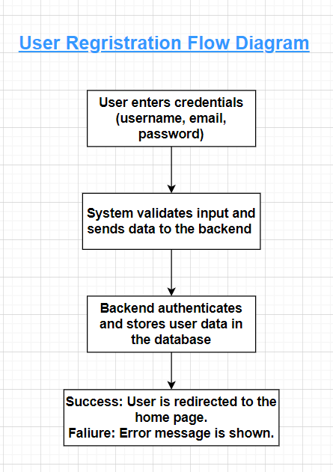

* Login Flow Diagram:

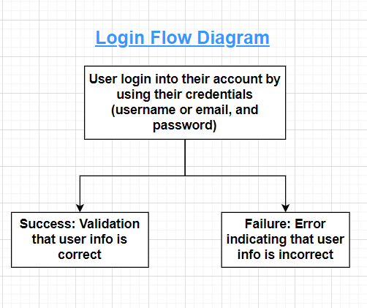

## Order Placement Flow Diagram:



**Project Schedule:**

| **Task** | **Effort (persons)** | **Duration (weeks)** | **Dependencies** |
| --- | --- | --- | --- |
| **Planning** | 5 | 1 |  |
| **Implementation** | 1 | 1 | T1 |
| **Coding: Index page** | 1 | 1 | T2 |
| **Coding: Images** | 1 | 1 | T2 |
| **Coding: Location/Your Area** | 1 | 1 | T3 |
| **Coding: Menu** | 2 | 4 | T4-T7 |
| **Coding: Order** | 2 | 4 | T4-T7 |
| **Coding: Cart/Checkout** | 2 | 4 | T4-T7 |
| **Coding: CSS/Design** | 2 | 4 | T4-T7 |
| **Debugging/**  **Troubleshooting** | 5 | 3 | T4-T10 |
| **Maintenance** | 2 | 8 | T12 |

**Monitoring and Reporting Mechanisms:**

Here are the following tools that will be used for communication, collaboration, and scheduling.

* **GitHub:** We will be using this platform for version control and code collaboration, providing code quality assurance and history tracking.
* **Discord:** This social platform will facilitate our communication and allow us to share our work amongst each other.
* **Group Text Messaging:** We will employ this form of communication to keep everyone updated and aligned on project developments.
* **Zoom:** We will be utilizing this communication platform for virtual meetings and collaborative discussions regarding our work.
* **Google Drive:** Google Drive will be our designated tool for document sharing and collaboration.
* **Trello:** This project management platform will facilitate task management and team collaboration while also helping to organize meetings and set deadlines for our project.

**Appendix**

| **Task** | **Description** | **Time(Weeks)** | **Dependencies** |
| --- | --- | --- | --- |
| **Planning** | Planning the project and the steps it will take to successfully complete our project. | 1 | None |
| **Implementation** | Discuss how we are going to implement our plan that we made. | 1 | T1 |
| **Coding: Images** | Downloading all the images that are needed for our website. | 1 | T2 |
| **Coding: Index Page** | Making the first page you see when you load up our website. | 1 | T2 |
| **Coding: Location** | Making the locations in which you are able to search near. | 1 | T3 |
| **Coding: Map** | Making a map that will show food places near your university. | 4 | T4-T7 |
| **Coding: Menu** | Making it so their menu is able to be provided. | 4 | T4-T7 |
| **Coding: Cart/Checkout** | Making the ability to add items to your cart. | 4 | T4-T7 |
| **Coding: CSS/Design** | Styling and designing the webpage. This will be done as we are doing each individual web page. | 4 | T2-T7 |
| **Debugging/**  **Troubleshooting** | Fix any issues with the website not working or code not properly functioning. | 3 | T4-T10 |
| **Maintenance** | Making updates to make sure our website is up to date with current coding standards. | 8 | T12 |